Project Title: Sales Performance & Regional Sales Dashboard

Company: Rivulet India Private Limited

Prepared By: Akash Kanjwani

Tool Used: Power BI

Date: July 2025

**1. Project Summary**

Objective:

To analyze overall sales performance, product-wise trends, and regional comparisons to support data-driven business decisions.

Tools Used:

Power BI, Power Query, DAX, Data Modeling, Interactive Visualizations

Outcome:

The dashboard helped visualize top-performing products, identify high-revenue regions, and understand monthly sales patterns.

These insights support better planning for inventory, marketing, and regional focus areas.

**2. Data Sources**

Excel File containing:

SalesData – transactional sales entries

ProducInfo – product names, categories, brands

StoreInfo – region-wise store details

InventoryData – units in stock, cost price, etc.

**3. Work Done / Project Steps**

1. Data Collection & Loading

Loaded Excel data into Power BI

Verified data types and formats

2. Data Cleaning & Transformation

Removed duplicates and nulls

Standardized column names

Converted data types (date, numeric)

3. Data Modeling

Defined relationships using ProductID and StoreID

Star schema created for performance

Cross-filtering enabled for interactivity

4. DAX Measures Creation

Total Sales, Total Units Sold, Average Selling Price, etc.

Region-wise and Brand-wise measures

Used DAX for clean dynamic aggregations

5. Dashboard Visualizations

KPI Cards for high-level stats

Product-wise Sales Bar Chart

Brand-wise Donut Chart

Region-wise Sales Bar Chart

Monthly Sales Line Chart

Slicers for Region, Store, Category, Month

6. Insight Generation

Identified top 5 selling products and brands

Tracked high-performing regions

Showed sales trend by month

Enabled interactive drill-down analysis

**5. Key Visuals**

1. KPI Cards – Summary Overview

Visual Type: Card  
Fields Used:

* Total Sales (DAX Measure)
* Total Units Sold (DAX Measure)

Purpose:  
These cards provide a quick overview of overall performance.  
They highlight important metrics in bold, so the user can quickly understand:

* How much total revenue was generated
* How many units were sold

2. Bar Chart – Product-wise Sales

Visual Type: Clustered Bar Chart  
Axis: Product Name  
Values: Total Sales

Purpose:  
This chart shows which products are performing the best in terms of sales.  
Helps in identifying:

* Top-selling products
* Products with low sales (at the bottom of the bar list)

Sorting:  
Descending order (highest selling product on top)

3. Donut Chart – Brand-wise Sales

Visual Type: Donut Chart  
Legend: Brand Name  
Values: Total Sales

Purpose:  
To show how much each brand contributes to the total sales.  
Easy to compare brands as portions of a circle (like a pie).

4. Donut Chart – Category-wise Units Sold

Visual Type: Donut Chart  
Legend: Product Category  
Values: Units Sold

Purpose:  
To compare how many units were sold in each product category.  
Good for understanding demand based on product type.

5. Line Chart – Monthly Sales Trend

Visual Type: Line Chart  
Axis (X): Month-Year (from Order Date)  
Values (Y): Total Sales

Purpose:  
To analyze the trend of sales over time (month by month).  
It helps in answering:

* Which months had peak sales?
* Are sales increasing or decreasing?

6. Bar Chart – Region-wise Sales Comparison

Visual Type: Clustered Column Chart   
Axis: Region Name  
Values: Total Sales

Purpose:  
To compare sales across different geographic regions.  
Helps in identifying:

* Which region is most profitable
* Which region needs attention or support

**6. Conclusion**

This project helped simulate a real-world sales analysis scenario using Power BI.

From loading and cleaning data to designing a fully functional interactive dashboard, all steps were handled end-to-end.

The final dashboard provides valuable insights for business decision-making.

**DashBoard**

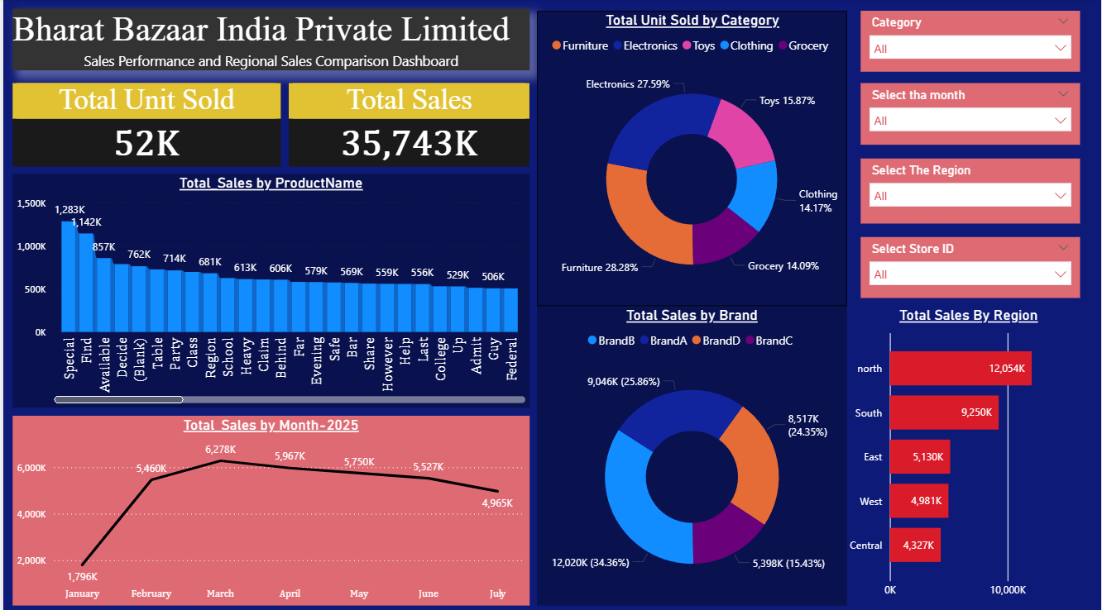

**Tips for Improving Sales & Growth**

**1. Focus on Top Performing Products & Brands**

**Insight:** Top 5 products are contributing highest in revenue  
**Tip:** Increase marketing and visibility of these products (bundling, display offers, online ads)

**2. Improve Sales in Low Performing Regions**

**Insight:** Some regions are generating very low sales  
**Tip:** Investigate reasons – poor stock availability, low footfall, or local demand mismatch Launch region-specific offers or promotions

**3. Seasonal/Monthly Sales Patterns**

**Insight:** Certain months have higher/lower sales  
**Tip:** Prepare for peak months in advance (stock, manpower, delivery) Run campaigns in low months to boost sales

**4. Inventory Optimization**

**Insight:** Some products have low sales but high stock  
**Tip:** Avoid overstocking low-demand items and use inventory reports to optimize purchase planning

**5. Customer Preferences by Region**

**Insight:** Different regions prefer different categories or brands  
**Tip:** Customize product offerings based on regional demand  
Example: North region prefers "Electronics" ,West prefers “Furniture”.

**6. Push Fast Moving & High-Margin Products**

**Insight:** Some products sell fast **and** have high profit margins  
**Tip:** Focus on cross-selling these items and Train sales teams to promote them actively

**7. Use Promotions Strategically**

**Insight:** Overall sales can be boosted by targeted discounts  
**Tip:** Run offers on slow-moving items or during slow months and Track promotion impact using before-after sales

**8. Customer Feedback & Store Experience**

**Tip :** Collect customer reviews regularly, Improve store layout, billing speed, staff behavior – it increases retention & word-of-mouth sales

**9. Leverage Digital Sales Channels**

**Tip:** Introduce online ordering for fast-moving products and Use WhatsApp marketing, local ads, and loyalty programs

**10. Use Dashboards for Regular Monitoring**

**Tip:** Check sales dashboard weekly/monthly and Identify drops or spikes quickly and take action immediately

**Conclusion -**

This Power BI project provided a complete end-to-end solution for analyzing sales performance and regional comparisons using real-world data.

From data cleaning, transformation, and modeling to advanced DAX calculations and dashboard design — each step was done with a focus on **business impact** and **decision-making**.

The interactive dashboard allows business users to:

* Track key performance indicators in real-time
* Understand product, category, and regional sales trends
* Make faster, data-driven decisions

As a Data Analyst, my role was not only to visualize the data, but to extract **actionable insights** and recommend strategic improvements that can help grow the business.

**This project showcases how data, when used effectively, can become a powerful asset for driving business growth, improving operations, and making informed decisions.**